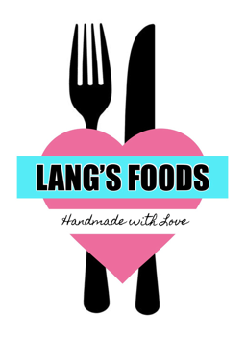

Lunch Order Form

This year we will have a Hot & Cold Drinks Stand positioned in the exhibition hall open to Stall Holders & the General Public this will be selling:
Tea, Coffee, Cold Drinks, Cakes, Chocolate Bars & Crisps

We are offering a pre-order service for items available from the Café upstairs

Your pre-order items will be ready to collect from the Drinks Stall in the Exhibition Hall at 11am & 2pm

Alternatively our full café menu is available to purchase from by going upstairs

Please return completed order form to Event Organisers by no later than 10am if you would like to place a pre-order

Hot Filled Rolls | Sandwich/Roll/Wrap | Other items
Bacon £5.00  Link Sausage £5.00  Scrambled Egg £5.00  Beef Burger £5.00  Cheese Burger £6.00  Bacon Cheese Burger £7.00  Sauces  Ketchup  Brown  Mustard  BBQ sauce | £5.00 each  Coronation Chicken  Egg Mayo  Tuna Mayo  Smoked Ham  Grated Cheese  Caramelised Onion Chutney  Lettuce, Tomato, Cucumber  Choose up to 2 fillings | Lentil Soup £3.00  With a buttered roll £4.00  With buttered bread £4.00  Chips £5.00  Chips & Cheese £6.00  Loaded fries £7.50  (Mac & Cheese)  Toasty of the Day £6.00  (BBQ chicken melt)

Write your order below
Time Slot chosen:
Exhibitor Name:

Stall Number:

